Aaron Burkhead, Tului Gantulga

Professor Mohamed M. Hafez

EME 199

December 8, 2016

**Introduction**

The purpose of this Special Study is to analyze a structure and its reactions under different kinds of loadings, such as purely its own weight, distributed loading, buckling, and torsion. Linear case is considered for all the scenarios and nonlinear cases are considered only for the cases where its own weight and distributed loading cause deflection. The main method used in this study is the Finite Difference Method (FDM). As the number sections increases, the result gets closer to the true deflection for both the linear and the nonlinear cases, and the Newton-Raphson method is used for nonlinear problems and as the number of repetitions gets bigger, it also approaches the true deflection. This method only works when the nonlinear part of the differential equation is raised to the power less than one, or else the deflection explodes. Due to the nature of the differential equations and its extension to matrices, the resulting matrices are in the form of a tridiagonal matrix. Thus, Thomas’ Algorithm is used to solve the matrices. To make sure we get the exact solution, at least close to the exact solution, we choose the simplest case for all cases and solve the equation analytically and compare the analytical solution to the discrete solution. To further simplify the equation, material properties and geometry are taken as constants.

**Bending of a String due to Its Own Weight (Linear)**

A simply supported string pulled down by its own weight is considered for analysis in this case. Suppose the string has property $ω \frac{N}{m}$, held up by tension forces T at both ends, and has a length of 1 meter. The following figure is used to derive the differential equation that is used.

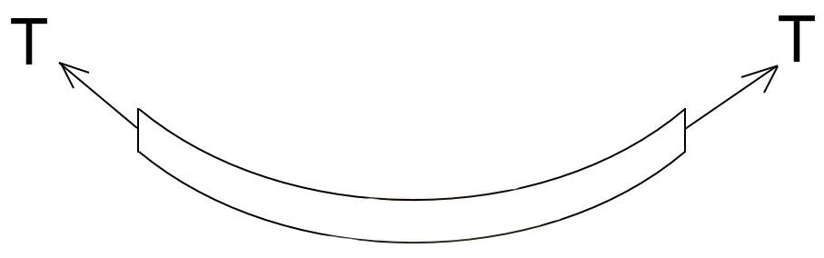

Further analysis of the above figure gives a very tiny chopped up piece zoomed in:

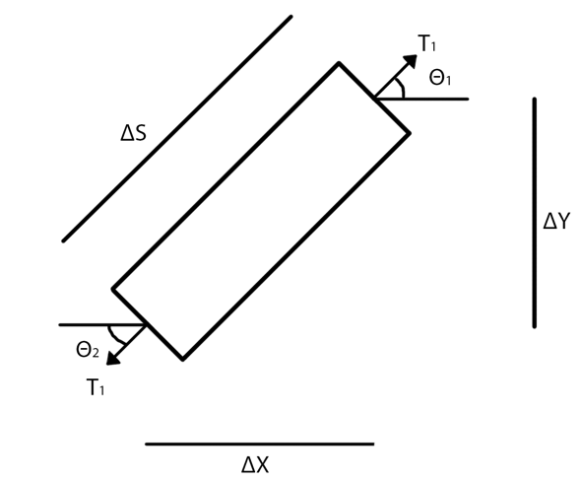

Equilibrium in the x-direction results in,

$ΣFx: T_{1}*cos\left(θ_{1}\right)-T_{2}*cos\left(θ_{2}\right)=0$ (1)

Equilibrium in the y-direction results in (for the linear case, we use $∆x$ and $∆s$ for nonlinear),

$ΣFy: T_{1}*sin\left(θ_{1}\right)-T_{2}*sin\left(θ_{2}\right)-w*∆x=0$ (2)

From Equation 1, we get that,

$T_{1}*cos\left(θ_{1}\right)=T_{2}*cos\left(θ_{2}\right)=H$ (3)

which we will call the horizontal force, and divide Equation 2 by Equation 3, we get that,

$\frac{T_{1}*sin\left(θ_{1}\right)}{T_{1}*cos\left(θ_{1}\right)}-\frac{T_{2}*sin\left(θ_{2}\right)}{T_{2}*cos\left(θ_{2}\right)}-\frac{w*∆x}{H}=0$ (4a)

Rearranging Equation 4a,

$\frac{T_{1}*sin\left(θ_{1}\right)}{T_{1}*cos\left(θ_{1}\right)}-\frac{T_{2}*sin\left(θ_{2}\right)}{T_{2}*cos\left(θ_{2}\right)}=\frac{w*∆x}{H}$ (4b)

Canceling variables out,

$\frac{sin\left(θ_{1}\right)}{cos\left(θ_{1}\right)}-\frac{sin\left(θ_{2}\right)}{cos\left(θ_{2}\right)}=\frac{w*∆x}{H}$ (4c)

Plugging in tan($θ$)=sin($θ$)/cos($θ$),

$\tan\left(θ_{1}\right)-tan⁡(θ_{2})=\frac{w*∆x}{H}$ (4d)

And we know that tan($θ$) gives the slope at a certain point which is equal to the derivative at that point and dividing both sides by $∆x$,

$\frac{{(\frac{dy}{dx})}_{1}-{(\frac{dy}{dx})}_{2}}{∆x}=\frac{w}{H}$ (4e)

Finally, we get,

$\frac{d^{2}y}{dx^{2}}=\frac{w}{H}$ (5)

We assumed that the small length that we are considering is $∆x$, but it is $∆s=\sqrt{{∆x}^{2}+{∆y}^{2}}$ and taking out the ${∆x}^{2}$, we get $∆s=∆x\sqrt{1+\frac{{∆y}^{2}}{{∆x}^{2}}}$. Multiplying the right side by $\frac{∆x\sqrt{1+\frac{{∆y}^{2}}{{∆x}^{2}}}}{∆x}$ to account for the linear assumption made earlier and to make it become nonlinear yields,

$\frac{d^{2}y}{dx^{2}}=\frac{w}{H}\sqrt{(1+{\left(\frac{dy}{dx}\right)}^{2})}$ (6)

Solving the linear analytically gives and putting in the boundary conditions y(o)=y(1)=0,

$y\left(x\right)=\frac{w}{2H}*x(1-x)$ (7)

and the nonlinear analytical solution is,

$y\left(x\right)=\frac{H}{w}[cosh⁡(\frac{wx}{H}+0.5*\ln\left(\frac{1-e^{-\frac{w}{H}}}{e^{\frac{w}{H}}-1}\right)-cosh⁡(0.5* ln⁡(\frac{1-e^{-\frac{w}{H}}}{e^{\frac{w}{H}}-1}$)) (8)

These two are compared with the discrete solution, which is defined as,

$\frac{y_{i-1}-2y_{i}+y_{i+1}}{{∆x}^{2}}=\frac{w}{H}$ (9)

Then the matrix looks as the following,

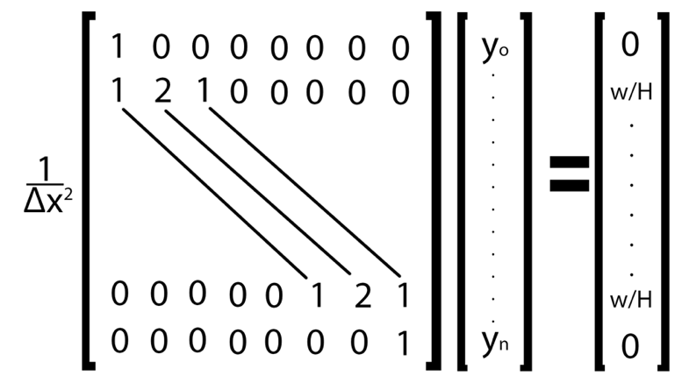

Solving the above equation and the 100x100 matrix with the given boundary conditions and w=H yields the following graph,

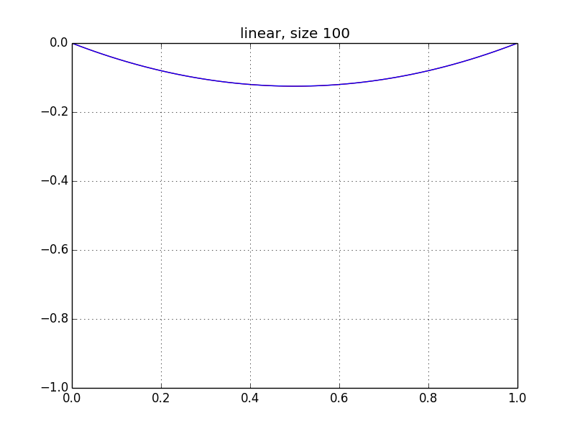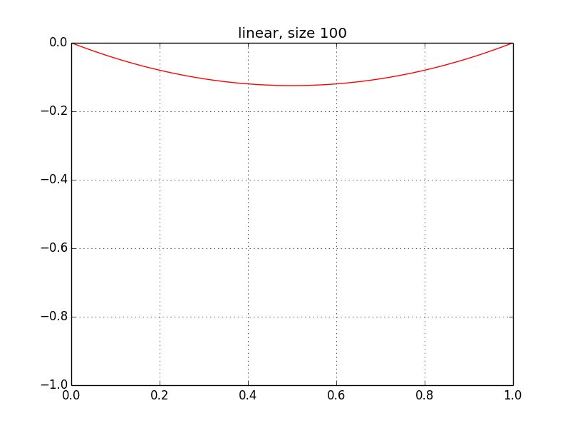

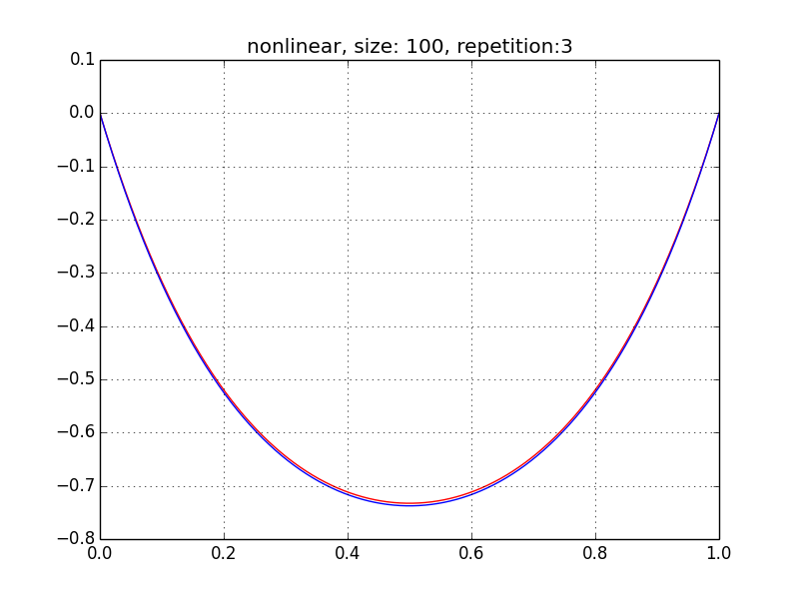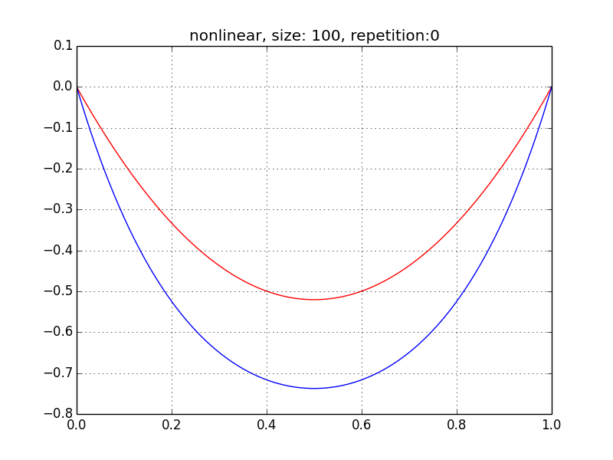and the nonlinear case with w=78970.5 N/m and H=18970 N yields the following,

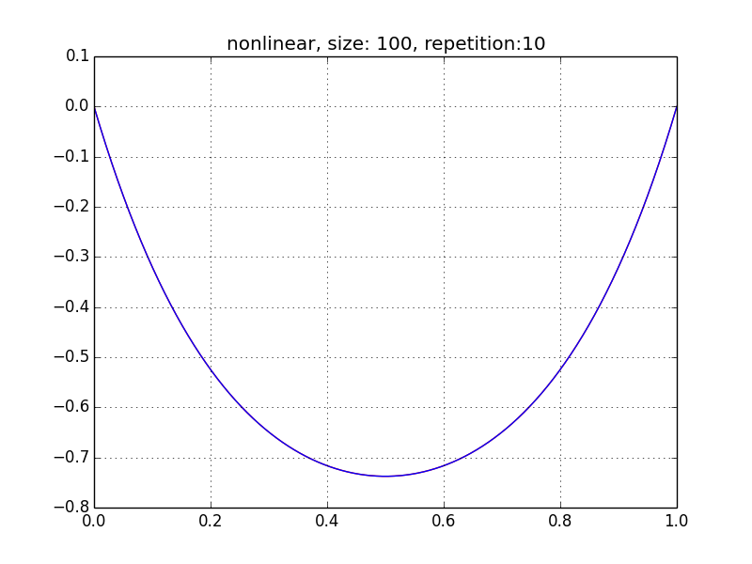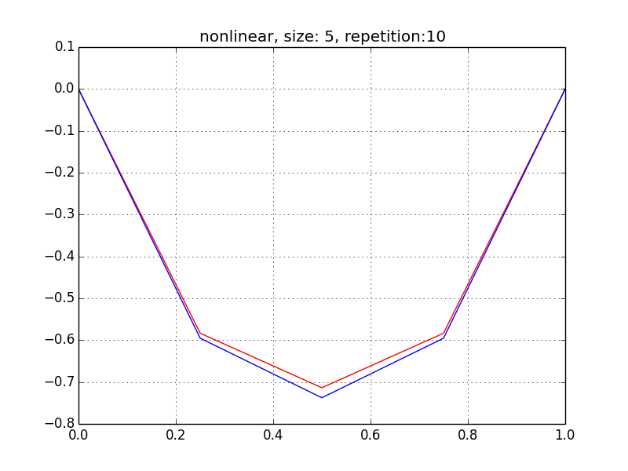

The blue curve shows the analytical solution and the red curve shows the discrete solution. Even after only 3 iterations, the discrete solution obtained through FDM is pretty much the same as the true deflection. There are two sources of error when using FDM. The first one depends on the size of the matrix, bigger matrix means smaller sections, thus the discrete solution mimics the analytical solution as the size of the matrix approaches infinity. The second one depends on the number of iteration, as the number of iteration increases, so does the accuracy. As shown in the above figures, even after 10 iterations, if the size is small, discrete will not approach the true deflection. The best scenario out of the above figures is when the size is 100 and it is iterated 10 times, at which point the discrete solution is the same as the true solution as far as the eye can tell at the current zoom level. As both the iteration and the size of the matrix increases, it will approach the true deflection.

**Buckling of a Beam**

The buckling of a beam is caused by the normal force applied at both ends. As the normal force increases, depending on the imperfection of the beam, the beam will buckle a certain way. The following figure shows the visualization of buckling. The figure on the left describes is described by,

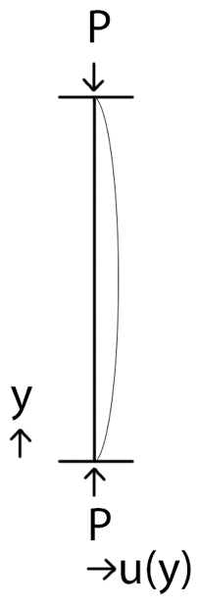 $M\left(y\right)-P*u=0$ (1)

$EI*\frac{d^{2}u}{dy^{2}}-P*u=0$ (2)

$\frac{d^{2}u}{dy^{2}}-\frac{P}{EI}*u=0$ (3)

Solving the equation with the boundary conditions u(0)=0 and u(1)=0 yields,

$u\left(y\right)=Asin\left(\sqrt{λ}y\right)$ (4)

It turns out that $λ=n^{2}π^{2}$, where $n=1,2,3…$ During this research, we have estimated the value of $λ$ because Eqn. 3 becomes an eigenvalue problem. As the number of sections (i.e. size of matrix) increase, the accuracy of the eigenvalue also increases. The discretization of the above problem is shown on the next page.

$\frac{y_{i-1}-2y_{i}+y_{i+1}}{{∆x}^{2}}+λy_{i}=\frac{w}{H}$ (5)

shown below is the discrete approach of the eigenvalue when n=1, thus $λ=π^{2}=9.8696$.

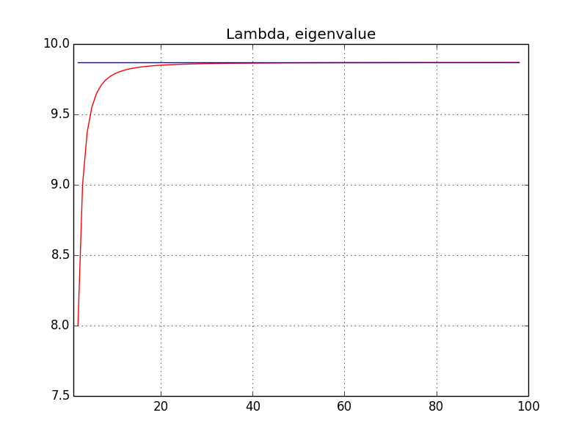

when n=2, $λ=2^{2}*π^{2}=39.47841$, the following is the result,

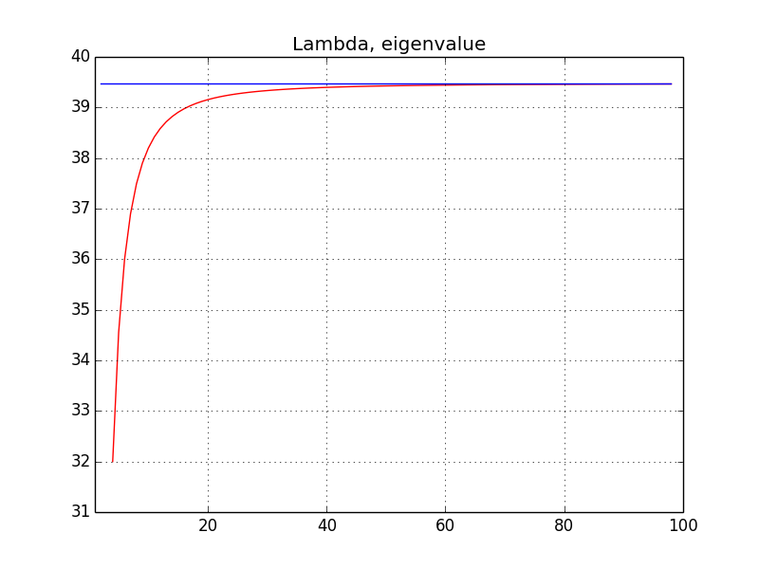

As is with the others, there is a correlation between the size of the matrix and the accuracy of the value. And the bigger the n value, the size of the matrix that yields an accurate value of $λ$. When n=1, the size of the matrix needed to get a good estimate of $λ$ is about 25 and when n=2, the size increases up to 55.